ABANDONED MINE INSPECTION FORM
Forest: Sierra District: Bass Lake Inspection Date: 7/14/2017
Name of Claim: Mclendon Mine Lode or Placer: Lode
Location of Claim: Site accessible from route 140 by going north on Foresta Road, crossing the Merced River, and then west on Incline Road. The mine is located across from Incline Road from Mclendon Beach Day Use Area. SW ¼ NW ¼ Sec. 22, R19E, T.3S, MDB&M.
Status of Mine (Number and type of openings, trash on site, etc.): Two adits are closed with metal gates and the third is securely foamed closed. There is still some remaining debris on site near adit 1.
Problems or concerns this inspection: Non concerns are present. Warning signs were still intact from previous placement.
Photos taken this inspection: Yes, see attached.
Inspected by: Danielle Parsons and Cody Ellis-Herring

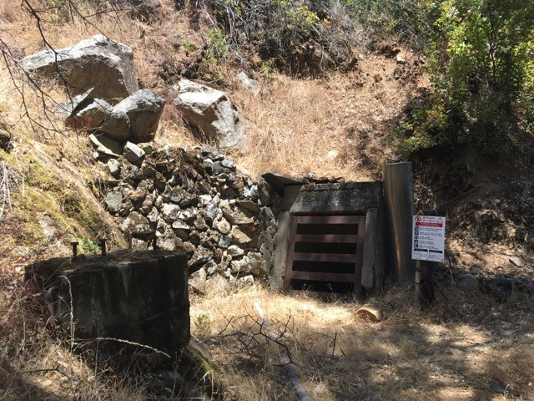
Figure 1. Warning sign next to adit 1 still intact.

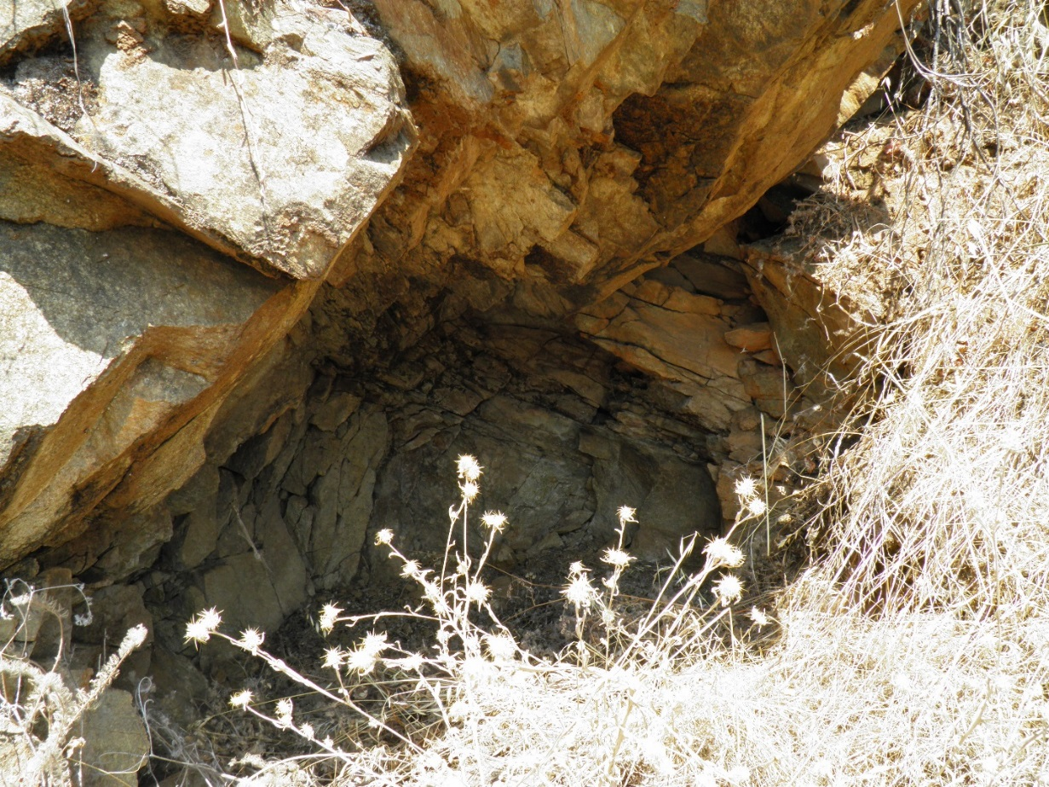
Figure 2. Closed foamed entrance of adit 3.

